

Lab # 12

Web Engineering Fall 2020



Instructor | Mr. Muhammad Ahmed
Student Name | Amna Nadeem
CMSID | 404366
Department | Computer Science
Semester | 7th

Lesson Set 12
Advance Laravel
and MySQL

Purpose | 1. | To get a basic awareness of Laravel
 | 2. | To get know basic features of Laravel i.e., routing, blade view, MVC.
 | 3. | To learn the basics of MySql.
 | 4. | Laravel installation and configuration.(XAMPP)
Procedure | 1.  2. | Students should read the Pre-lab Reading assignment before coming to the lab.  Students should complete the Pre-lab Writing assignment before entering the
 | 3. | lab.  In the lab, students should complete Labs 8.1 through 8.2 in sequence. Your
 | 4. | instructor will give further instructions as to grading and completion of the lab.  Students should complete the set of lab tasks before the next lab and get
 |  | them checked by their lab instructor.

Contents | Pre-requisites | Completion Time | Page Number
Pre-lab Reading Assignment | - | 20 min | 3
Pre-lab Writing Assignment | Pre-lab Reading | 10 min | 4
Lab 12
Lab 12.1  Laravel and MySQL | Pre-lab reading | 30 min | 5
Lab 12.2  Lab Tasks | Awareness of laravel and MySQL advance | - | 9

PRE-LAB READING ASSIGNMENT

Laravel

Key Components of Laravel
Laravel is a modern, open-source PHP web application framework designed to make web development faster, cleaner, and more efficient. It follows the MVC (Model–View–Controller) architecture, which separates the application into logical layers and improves organization, scalability, and maintainability.
Laravel provides developers with a powerful set of tools, built-in features, and elegant syntax that simplifies complex tasks like routing, authentication, database operations, session handling, and APIs. Its goal is to make development enjoyable and productive.
1. Routing

Routing controls which URL triggers which action or page in the application.
Laravel’s routing is simple and powerful, allowing you to handle requests with clear and readable code.

Route::get('/home', [HomeController::class, 'index']);

2. Controllers
Controllers are responsible for handling user requests, processing logic, and returning responses.They act as the brain between the Models (data) and Views (UI).Example:

3. Models

Models represent database tables and allow easy data interaction using Eloquent ORM. Instead of writing SQL queries, developers interact with the database through Models.

4. Views (Blade Templates)

Views are responsible for the user interface.Laravel uses Blade, a lightweight templating engine, to create dynamic HTML pages with simple syntax.

5. Eloquent ORM

Eloquent (Laravel’s ORM) allows developers to interact with the database using PHP objects instead of SQL. It helps define relationships, retrieve data, and perform CRUD operations easily.
6. Middleware

Middleware filters incoming HTTP requests.
It is used for authentication checks, security, logging, etc.

Example: Only logged-in users can access a route using the auth middleware.

7. Migrations

Migrations handle the database structure (tables, columns).
They allow version control of the database, so teams can collaborate easily.

8. Artisan CLI

Artisan is Laravel’s command-line tool used to automate tasks such as creating models, controllers, running migrations, clearing cache, etc.

MySQL:

MySQL is a popular, open-source Relational Database Management System (RDBMS) used for storing and managing data.
It organizes information into tables (rows and columns) and supports SQL (Structured Query Language) for performing operations like inserting, updating, deleting, and retrieving data.

MySQL is reliable, fast, secure, and widely used in web applications, including Laravel. It is also the default choice for many PHP-based systems and is compatible with tools like phpMyAdmin for easy management.
PRELAB WRITING ASSIGNMENT
Fill in the blanks | - Laravel follows the Model-View-Controller (MVC) architecture to organize application logic.  - In Laravel, the Eloquent ORM is used to interact with the database without writing SQL queries.  - The Blade templating engine is used in Laravel to build dynamic HTML views.  - MySQL stores data inside tables, which are made up of rows and columns.  - In MySQL, a Primary key uniquely identifies each record in a table.

Lab 12.2 LAB TASK
Task: From pervious lab 11 extend the MiniLMS with laravel & MySQL:

In this lab, students will add some more modules (i.e., “student” & “teacher”) in the previous created Mini Learning Management System (Mini-LMS) using Laravel and MySQL. Also students will change the main interface of Mini LMS to proper UI.

- Extension of MiniLMS

  - The faculty Module must enable users to add new teachers by entering their name, email, phone number, and department. The system stores each teacher in the database and displays a list of all existing faculty members.

  - Similarly, the Student Module provides functionality to add students by capturing details such as name, email, phone number, roll number, and academic program. All student records are stored in the database and shown in a complete list for easy management.

Notes:
- Provide screen shots.
- Upload into GitHub pages and provide a link in the given box below.
- Focus on writing clean, modular, and maintainable code.

Output:

After registering,

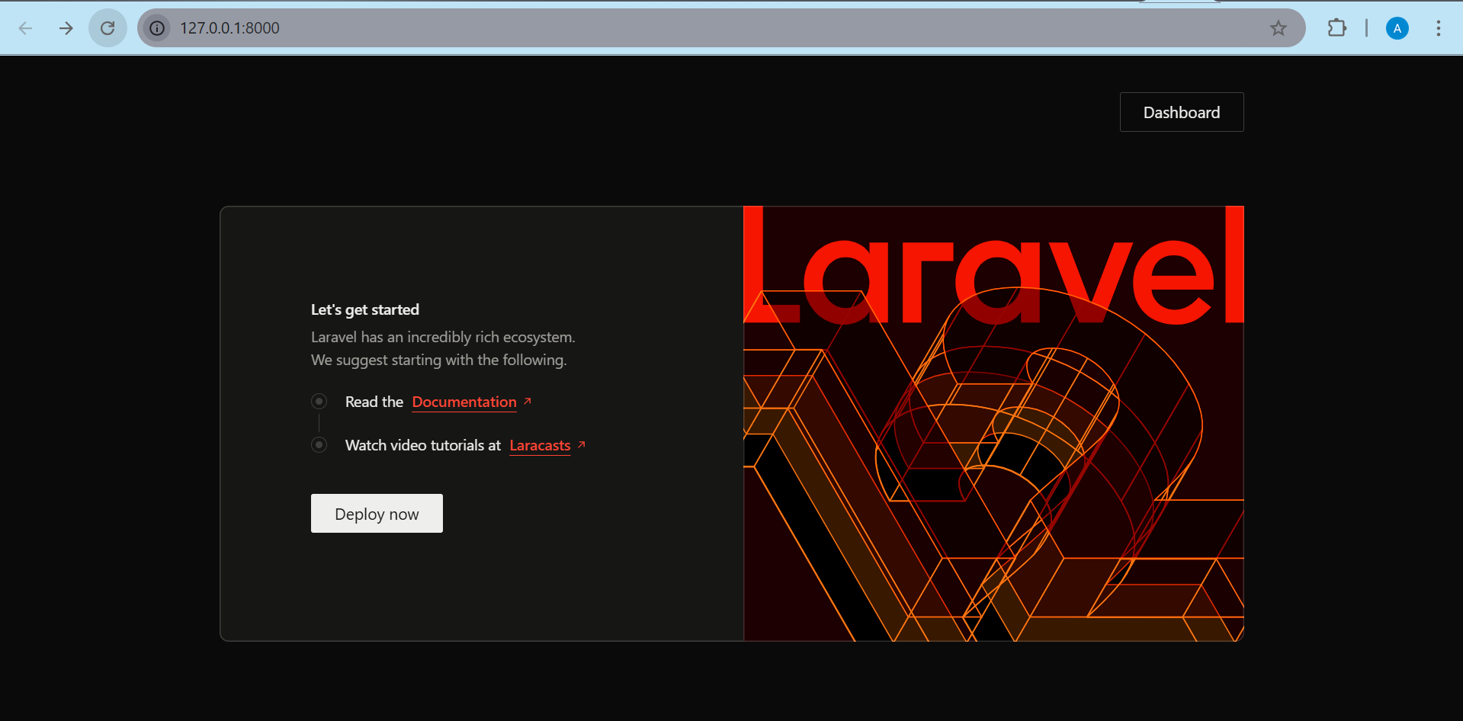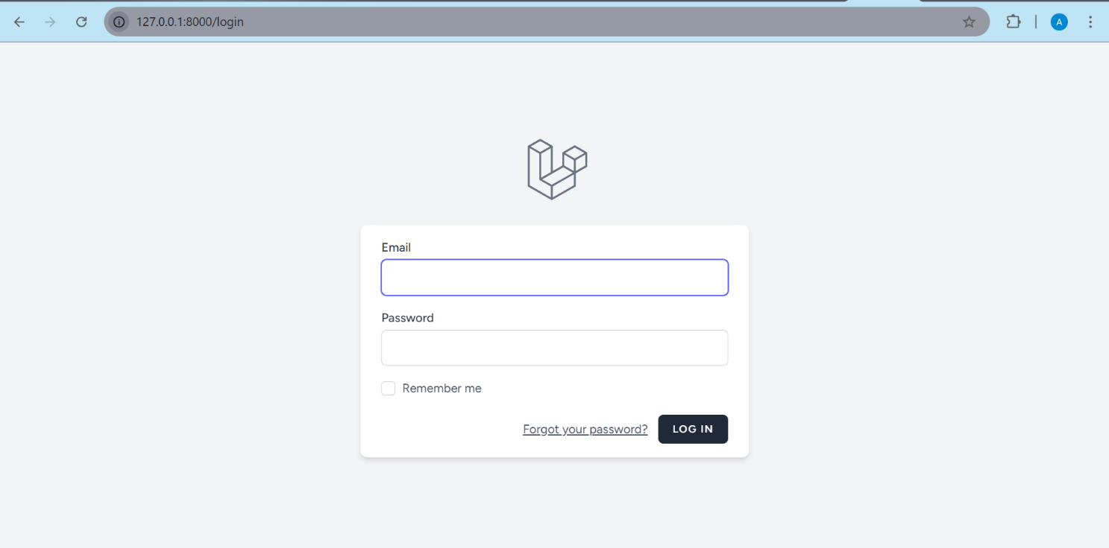
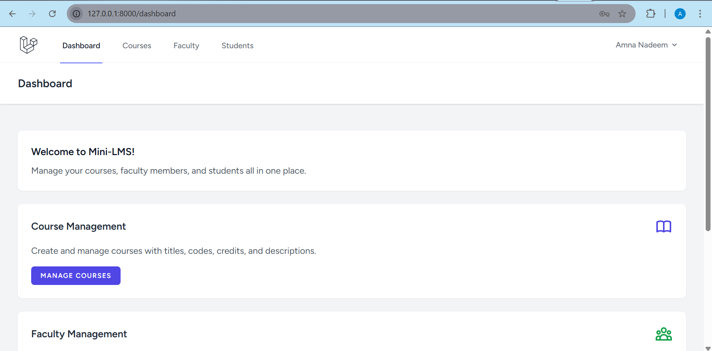

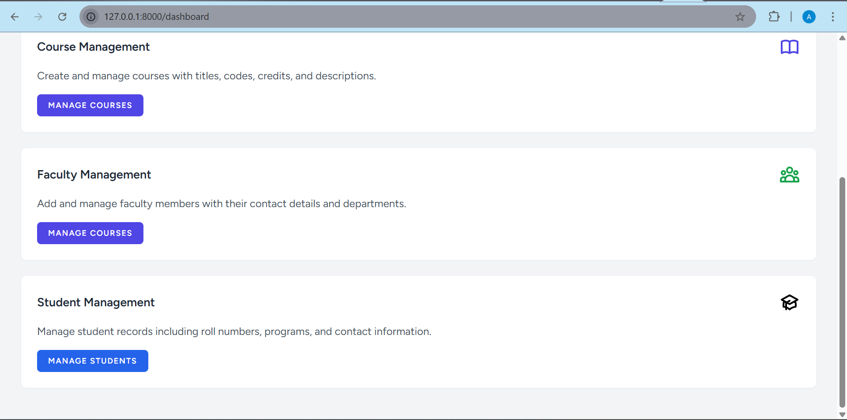

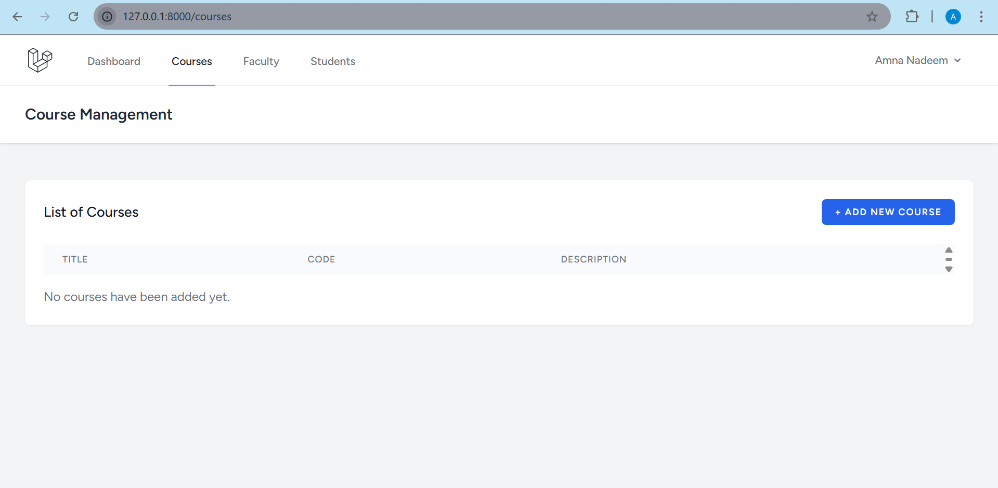
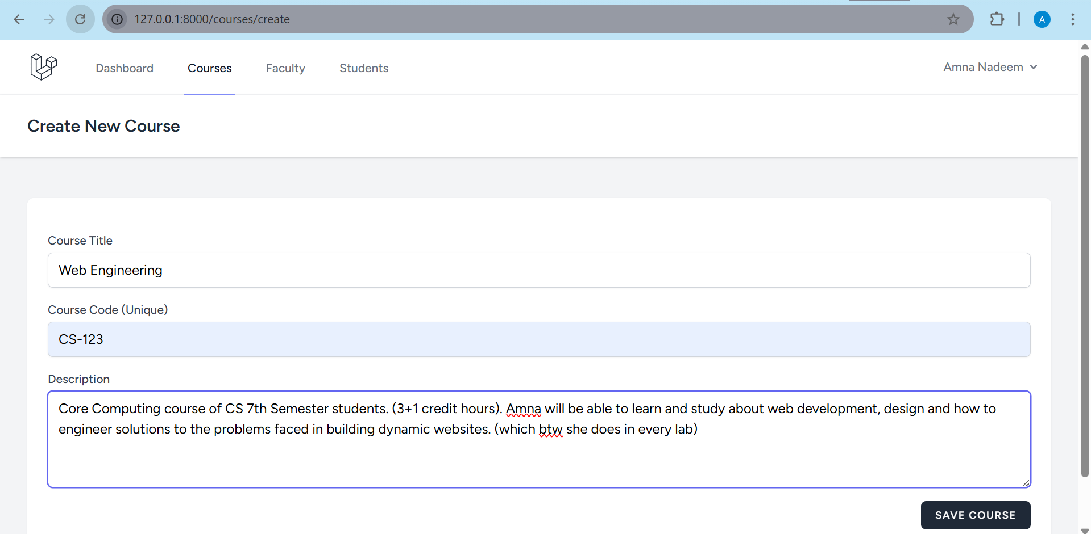

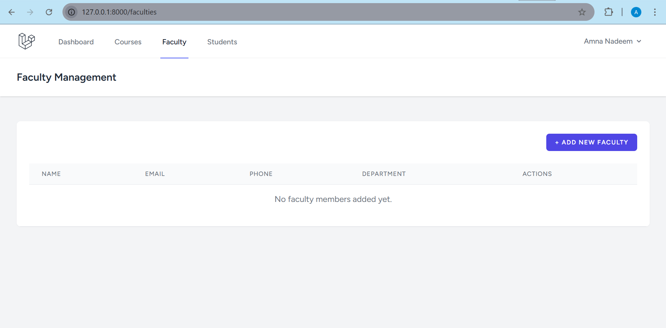

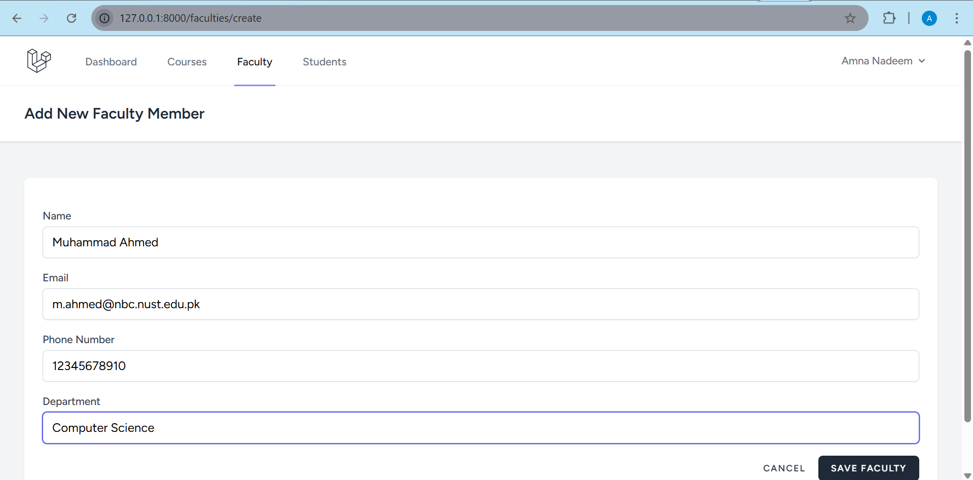

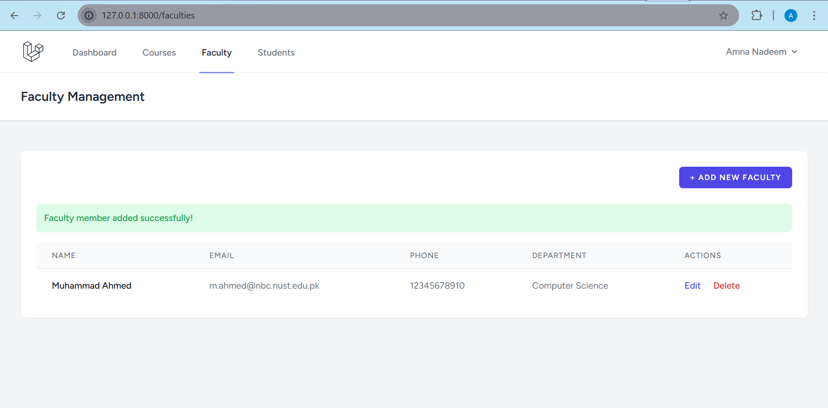

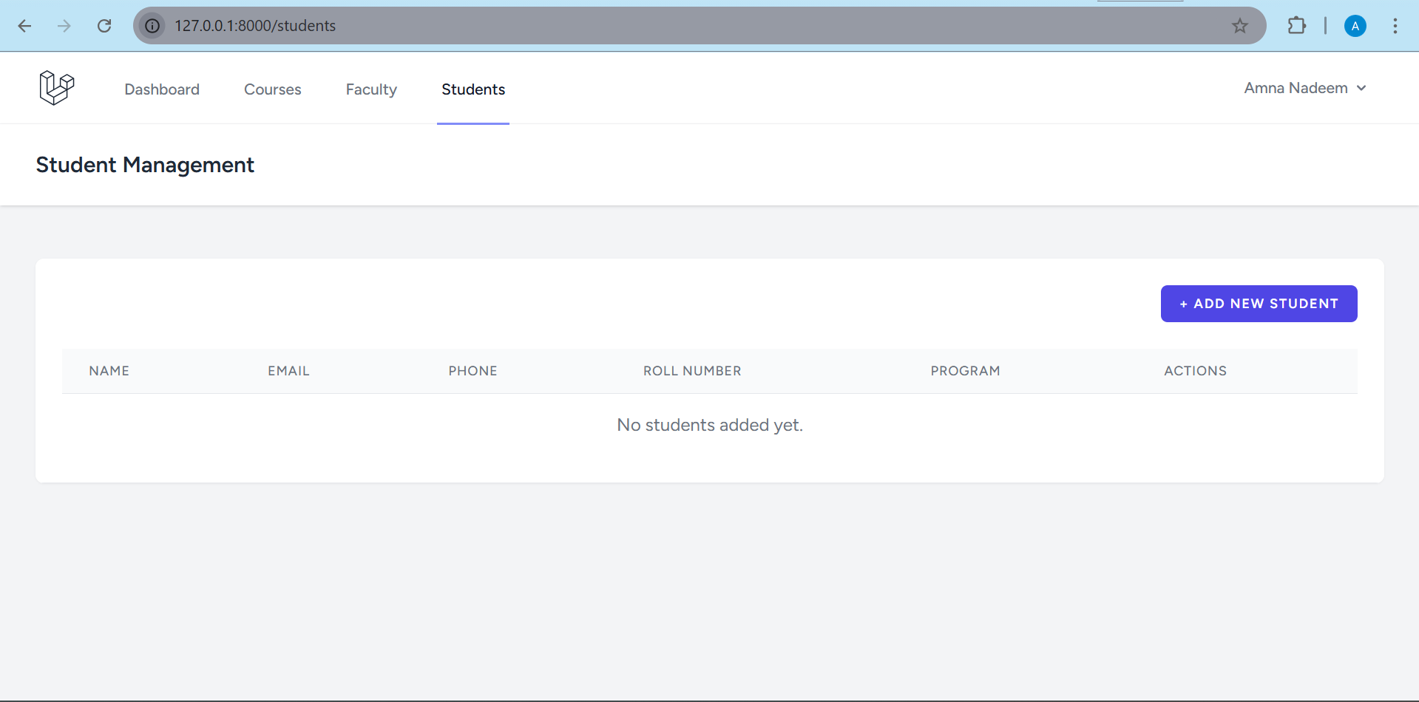

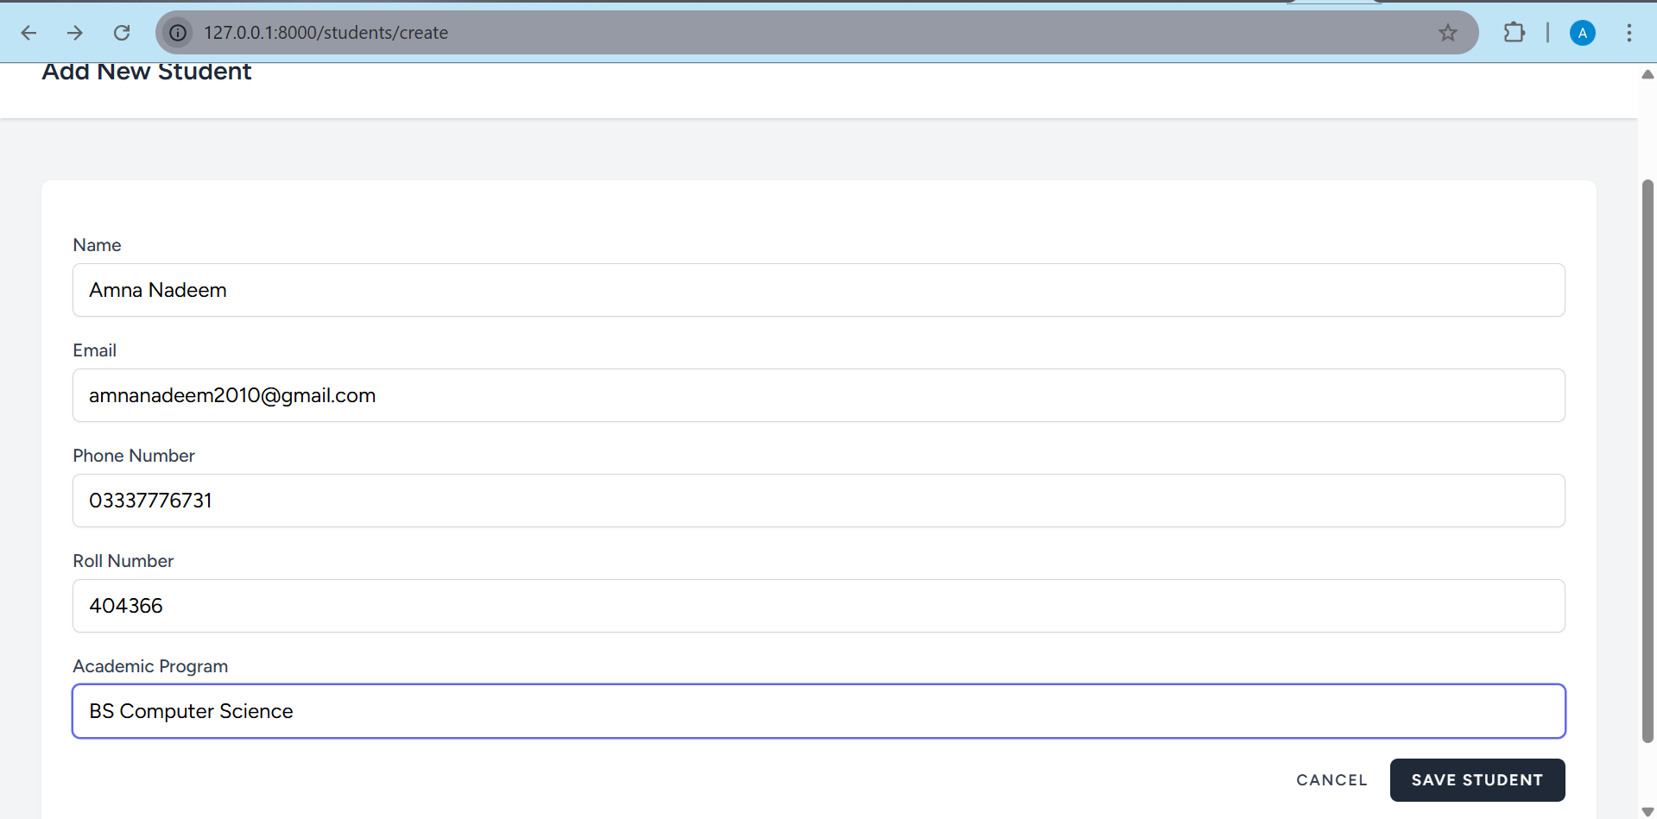

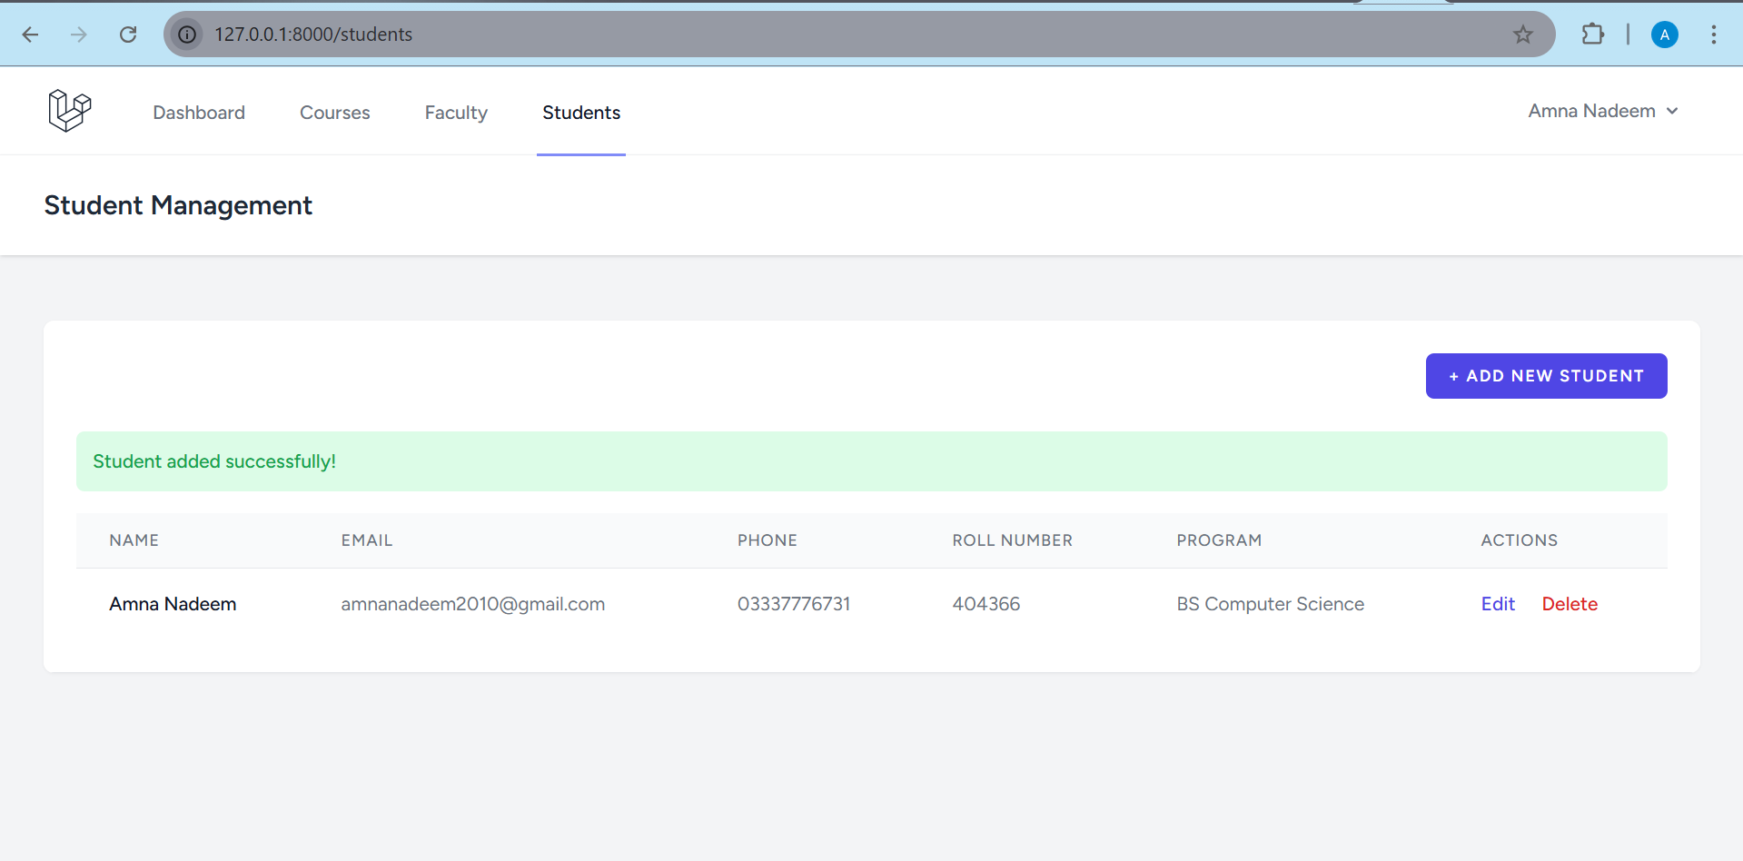

GitHub Link: https://github.com/Amna-Nadeem2003/Mini-LMS/tree/main/htdocs/MiniLMS

